IPLOOK

🔹 Definition
# Source: ScreenShots Source: Provided by: [Persons Table -> ID Column: 1, Name_En Column: Motasem Essam] -> Tool: [Lightshot Program] -> From [Site: https://www.iplook.com/] on [1/23/2026]
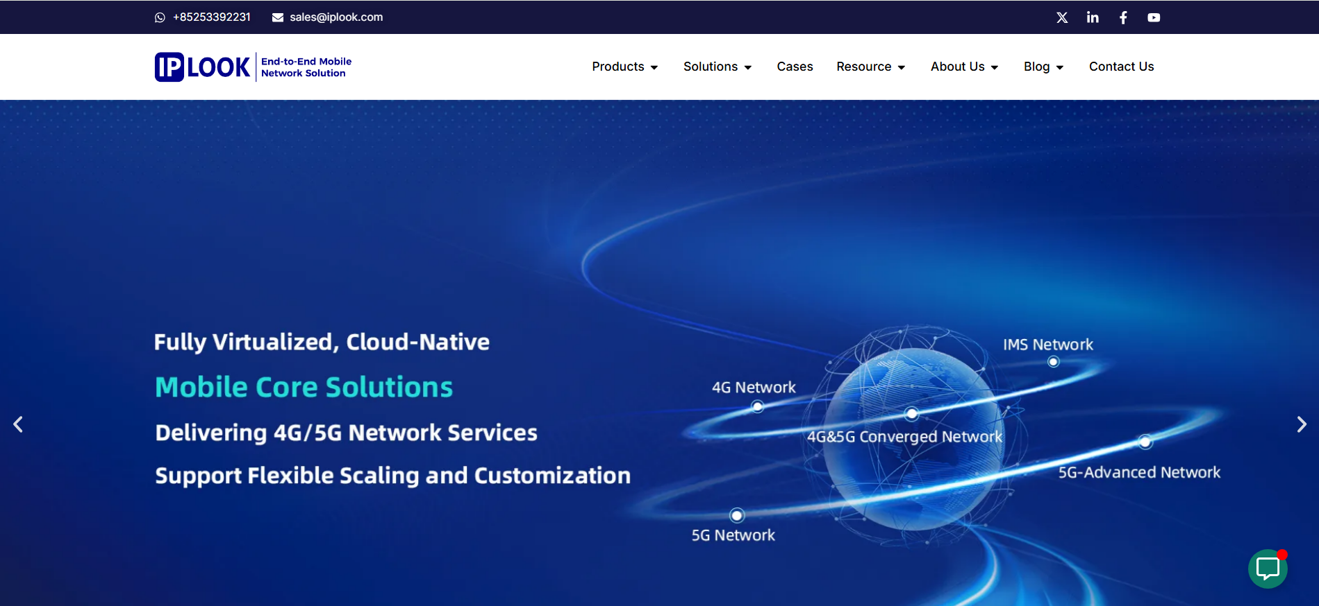
# Source: AI Source: Provided by: [Data Path: Persons Table -> ID Column: 1, Name_En Column: Motasem Essam] -> From: [ChatGPT] on [1/23/2026]
IPLOOK (accessible at https://www.iplook.com) is a global telecommunications technology company that specializes in mobile core network solutions for wireless operators and service providers. (IPLOOK)

📌 What IPLOOK Is
# Source: AI Source: Provided by: [Data Path: Persons Table -> ID Column: 1, Name_En Column: Motasem Essam] -> From: [ChatGPT] on [1/23/2026]
- Full-stack mobile core network provider: IPLOOK develops and delivers end-to-end software for mobile network cores — including 3G, 4G (EPC), IMS (IP Multimedia Subsystem), and 5G Core (5GC) — that act as the brains of a cellular network. (IPLOOK)
- Cloud-native & virtualized telecom solutions: Its platforms are designed to run in modern cloud environments and support scalable, flexible deployment models suited to both large operators and private networks. (IPLOOK)
- Serves global operators: The company’s solutions are deployed in more than 50 countries, connecting tens of millions of subscribers worldwide. (IPLOOK)

🛠 What They Offer
# Source: AI Source: Provided by: [Data Path: Persons Table -> ID Column: 1, Name_En Column: Motasem Essam] -> From: [ChatGPT] on [1/23/2026]
IPLOOK’s products and services include:
- 5G Core (5GC) and 4G EPC (Evolved Packet Core)
- IMS for voice and multimedia services
- Mobile operator support platforms for MNOs (Mobile Network Operators), MVNOs (Mobile Virtual Network Operators), WISPs (Wireless Internet Service Providers), and private LTE/5G networks
- Support for emerging technologies like VoWiFi, NB-IoT, MEC (Multi-access Edge Computing), and satellite-integrated networking (IPLOOK)

🌍 Company Profile
# Source: AI Source: Provided by: [Data Path: Persons Table -> ID Column: 1, Name_En Column: Motasem Essam] -> From: [ChatGPT] on [1/23/2026]
- Founded: 2012 (IPLOOK)
- Headquarters: Hong Kong, with a large R&D presence in Guangzhou and offices in multiple regions including Europe, Africa, and Asia. (LinkedIn)
- Workforce: Hundreds of employees, with a high percentage in R&D roles. (IPLOOK)
- Industry Association Memberships: Member of global telecom standards and industry groups such as GSA, TIP, and others, reflecting active participation in advancing mobile technologies. (IPLOOK)

🔍 Use Cases
# Source: AI Source: Provided by: [Data Path: Persons Table -> ID Column: 1, Name_En Column: Motasem Essam] -> From: [ChatGPT] on [1/23/2026]
IPLOOK’s solutions are used by:
- Telecom operators implementing or evolving mobile networks
- MVNOs and private networks needing tailored connectivity solutions
- Enterprises building dedicated wireless infrastructures
- Global carriers migrating from legacy systems to 4G/5G architectures (IPLOOK)
In simple terms, IPLOOK builds the software backbone that lets mobile networks function, handle traffic, authenticate users, and deliver services — much like how a server backend powers a large web application, but for cellular communications. (IPLOOK)

